Lab Report 3
Problem Statement: Implement and compare Merge Sort and Quick Sort algorithms for sorting a set of unsorted data

Objectives:
- To understand the working principles of Merge Sort and Quick Sort algorithms.
- To implement Merge Sort and Quick Sort using a programming language.
- To compare the performance and efficiency of both sorting algorithms.
- To develop problem-solving and algorithm design skills through sorting techniques.
Merge Sort
Source Code: Input & Output:
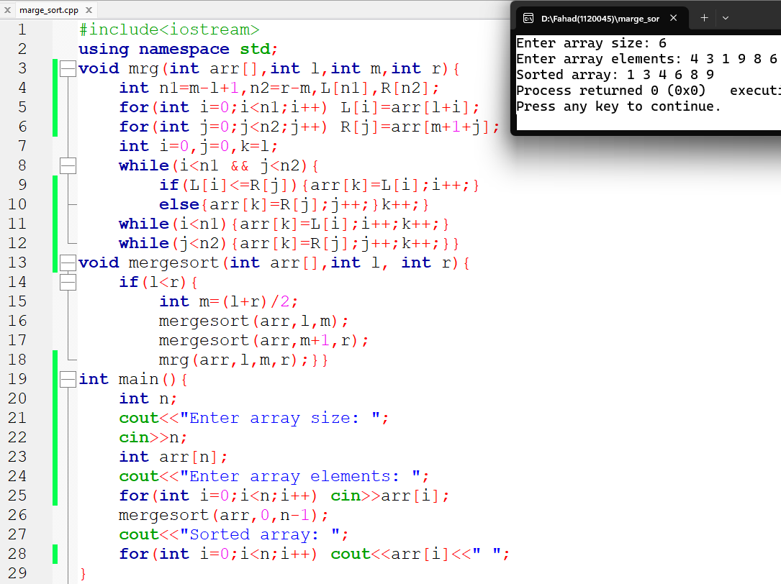

Quick Sort
Source Code: Input & Output:
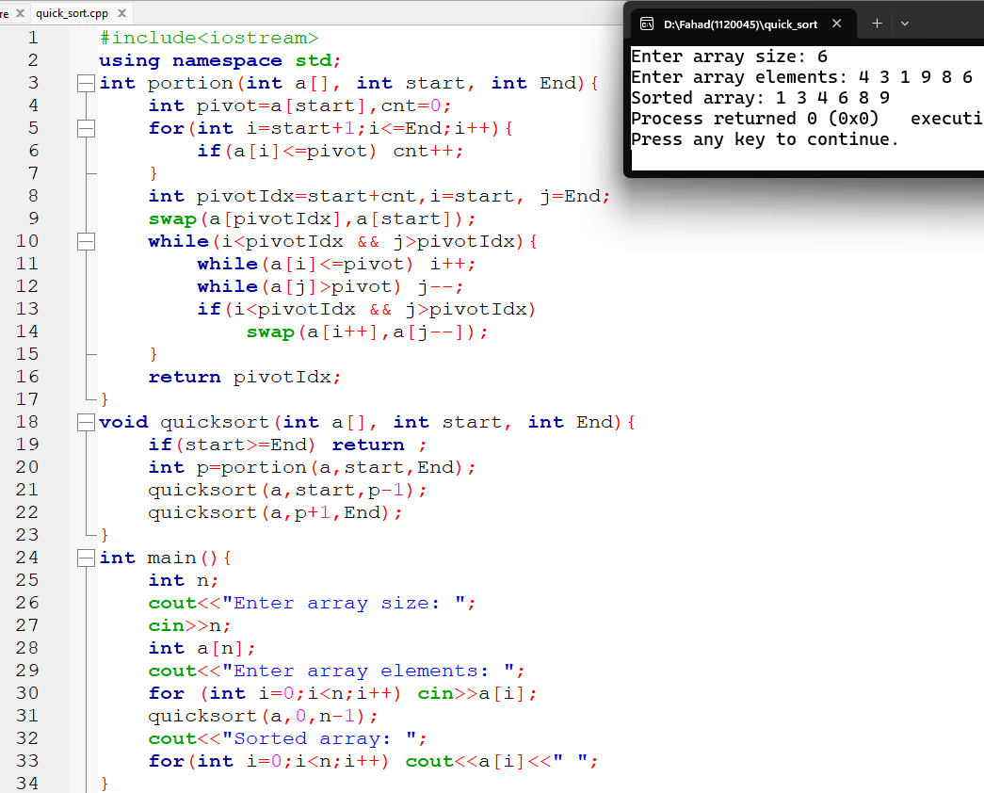

Conclusion:
In this lab, Merge Sort and Quick Sort were successfully implemented and tested with unsorted data. Both algorithms correctly sorted the given numbers in ascending order. Merge Sort was found to follow the divide-and-conquer method with stable performance, while Quick Sort worked faster in many cases due to efficient partitioning. Through this experiment, the concepts of sorting algorithms, recursion, and algorithm efficiency became clearer. Overall, the lab helped in gaining practical knowledge about advanced sorting techniques and their real-life importance in computer science.

